Kendriya Vidyalaya SPM Narmadapuram
Co- Curricular Activities CALENDAR
Wg- 2023-24
SESSION—2023-24
 | 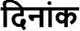
 | DATE | ACTIVITY
1 | 4-14-2023 | 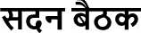
 |  | HOUSE MEETING
2 | 4-29-2023 | 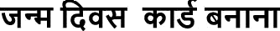
 |  | BIRTHDAY CARD MAKING
3 | 6-24-2023
 |  | CLASS ROOM DECORATION
3 | 7-1-2023 | 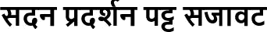
 |  | HOUSE DISPLAY BOARD DECORATION
GREETING/ WELCOME CARD
COMPETITION
5 | 7-22-2023 | 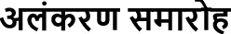
 |  | INVESTITURE CEREMONY
6 | 8-5-2023 | 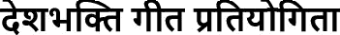
 |  | PATRIOTIC SONG COMPETITION
7 | 8-19-2023 | 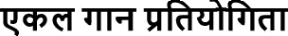

 |  | SOLO SONG COMPETITION
8 | 8-26-2023 | 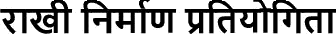
 |  | RAKHI MAKING COMPETITION
9 | 9-2-2023 | 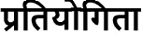
 |  | POSTER MAKING COMPETITION
10 | 9-16-2023 | 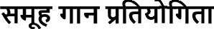
 |  | GROUP SONG COMPETITION
11 | 9-23-2023
 |  | TRADITIONAL DRESS COMPETITION
12 | 9-30-2023
 |  | HINDI SKIT / DRAMA COMPETITION
13 | 10-7-2023 | 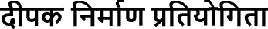
 |  | DIYA MAKING COMPETITION
14 | 11-4-2023 | 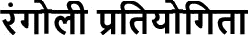
 |  | RANGOLI MAKING COMPETITION
15 | 11-18-2023 | 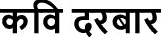
 |  | KAVI DARBAR
16 | 11-25-2023
 |  | DRAWING AND PAINTING COMPETITION
17 | 12-2-2023 | 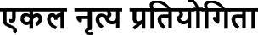
 |  | SOLO DANCE COMPETITION
18 | 12-15-2023 | 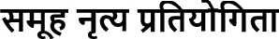
 |  | GROUP DANCE COMPETITION
19 | 12-23-2023
 |  | EXTEMPORE
20 | 1-6-2024 | 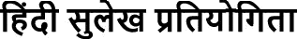
 |  | HINDI CALLIGRAPHY COMPETITION
21 | 1-20-2024 | 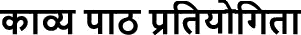
 |  | POEM RECITATION COMPETITION

22 | 1-27-2024 | 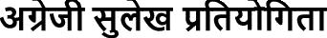
 |  | ENGLISH CALLIGRAPHY COMPETITION
Committee | Members | M r. P.K. Kori ( PGT Englis h)
 |  | Mr. S.K. Nag (TGT English)
 |  | Mr. As hi s h Dixit (TGT S kt.)
 |  | Mrs. Deepti Lodwal (TGT Hindi)
 |  |  | 